How to Build SQL Server 2022 DBA Real Time Home Lab   
in VMware workstation [Multi Subnet Environment]

**Hardware Minimum Requirements:**

Virtualization support in Bios

8 GB RAM

2.5 GH processer or more

500 HDD or 1TB HDD | SSD would be faster.

**Other Requirements:**64 Bit OS (windows 7/8/10)

VMware workstation **or** hyper v **or** Virtual Box

Windows SQL Server 2022

Windows Server 2022

**My environment:**

32 GB Ram

1 TB SSD & 1 TB HDD

Intel with 4 physical cores with virtualization support (4x2=8Cores)

Windows 10 64 bit os

Vmware workstation 17 Pro

Demo Configuration:

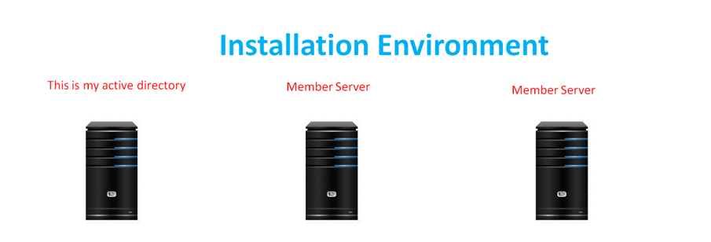

**Host Name: DC Host Name: Node1 Host Name: Node2**

**Memory: 4 GB Memory: 8 GB Memory: 8 GB**

**CPU: 1 processor with 2 Cores CPU: 1 processor with 2 Cores CPU: 1 processor with 2 Cores**

**OS: Windows Server 2022 OS: Windows Server 2022 OS: Windows Server 2022**

**Domain: Abc.com Domain: Abc.com Domain: Abc.com**

**Basics steps we need to check For Error Free installation**

1. All Member servers should be part of the Domain

2. Firewall should be off

3. Check communication between and Domain and member servers

4. Check Nslookup for all servers (it means DNS is resolving hostname to IP and vice versa)

5. Login with Domain administrator or user which is having Domain Level Permissions every where

**Step By step:**

1. Enable Virtualization (VT) In BIOS
2. Install VMware workstation
3. Create two switches in VMware virtual network adapter as shown in the below Image  
   Edit🡪Virtual Network adapter.  
   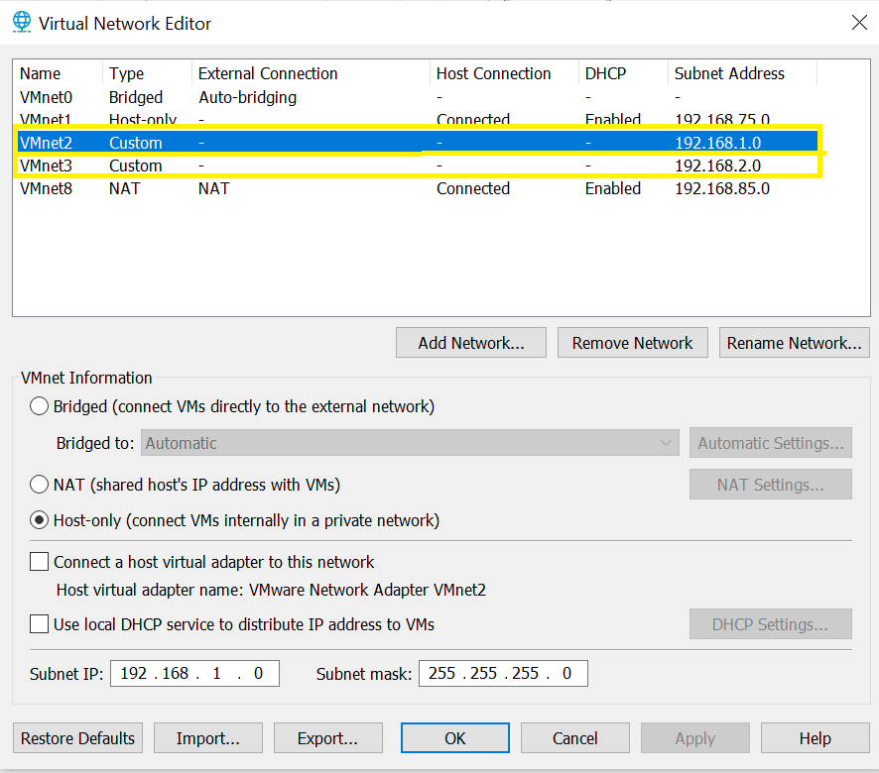
4. Install 3 Windows Server OS and Place with configure vm with respective Ips as shown in the snap.

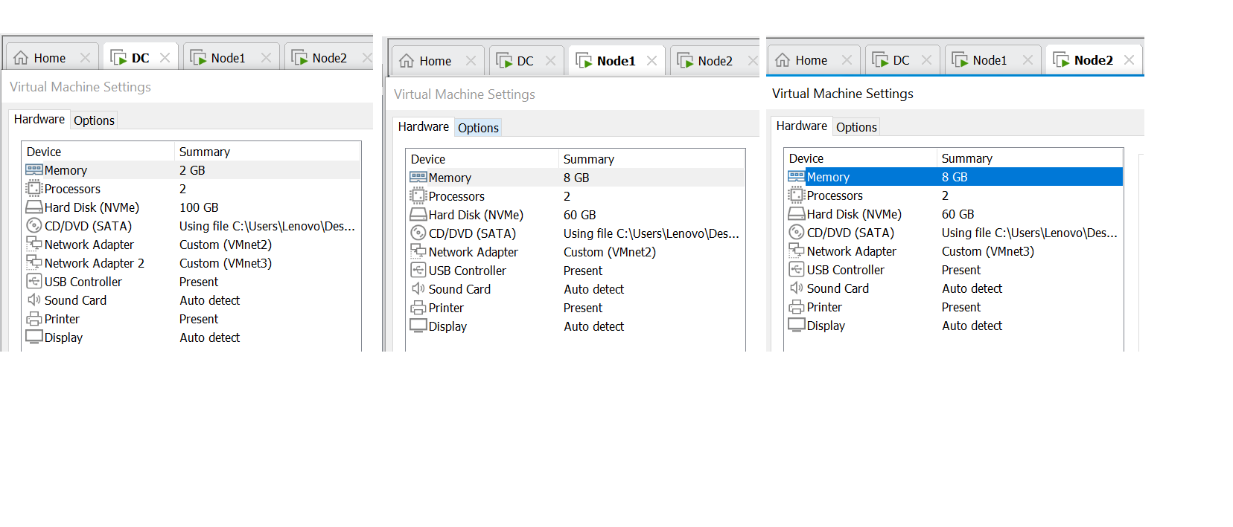

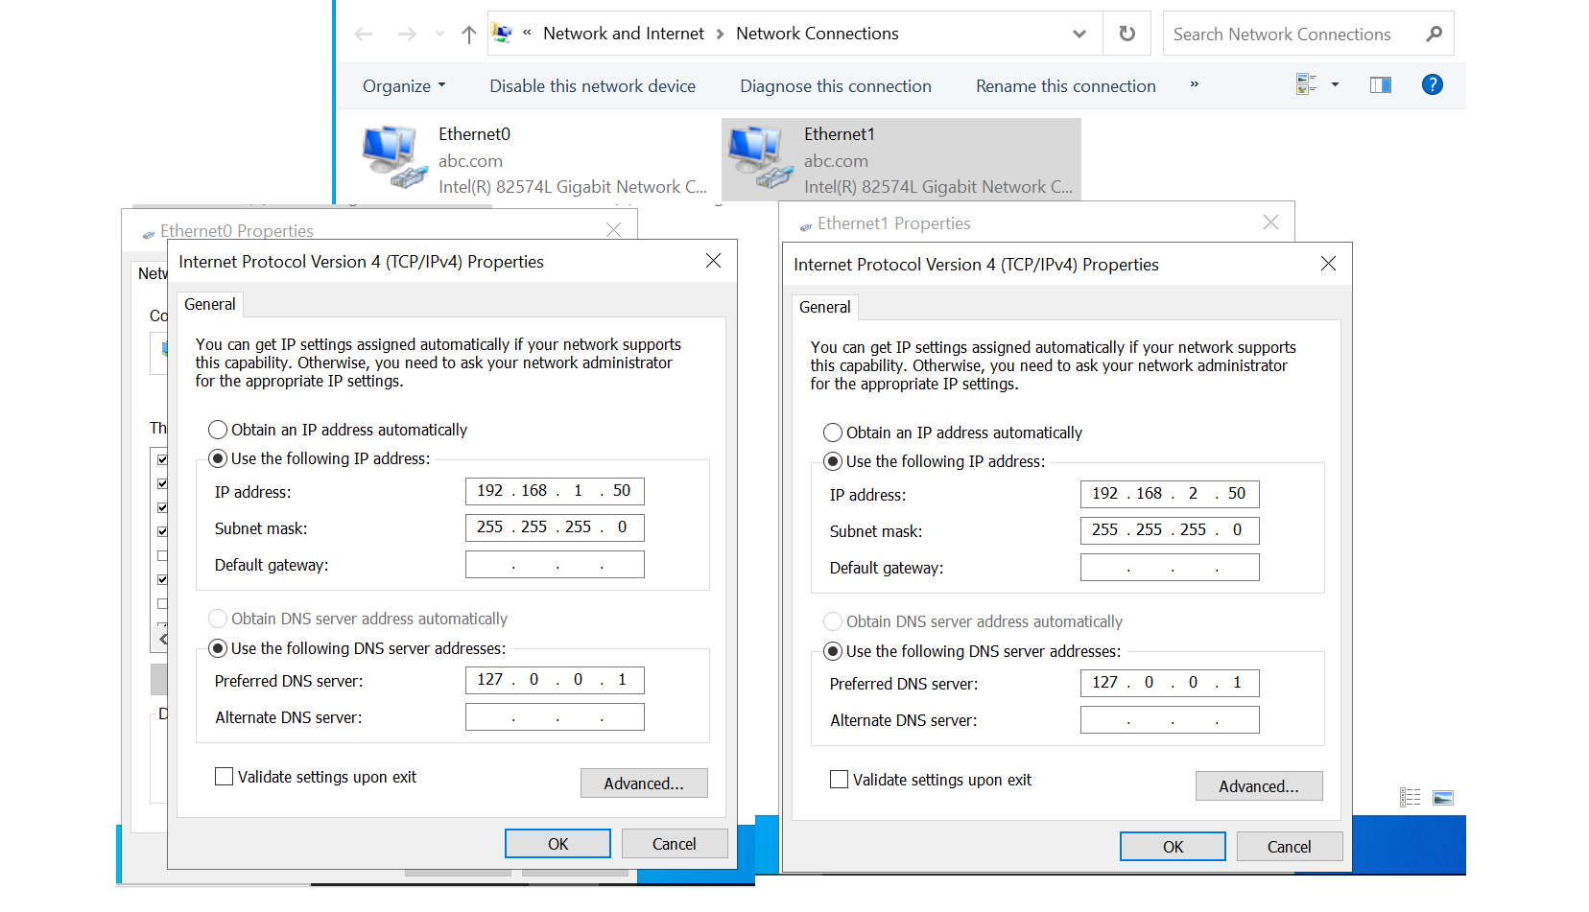

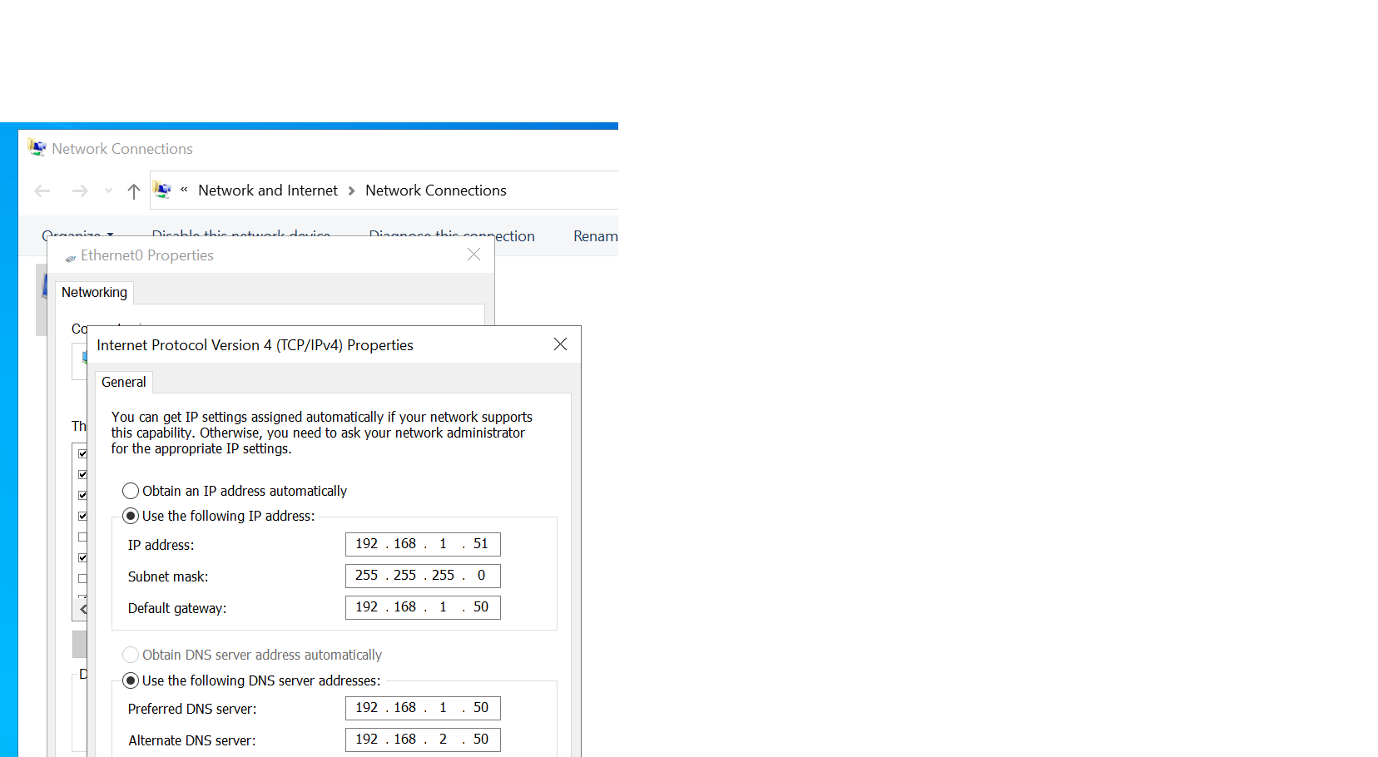

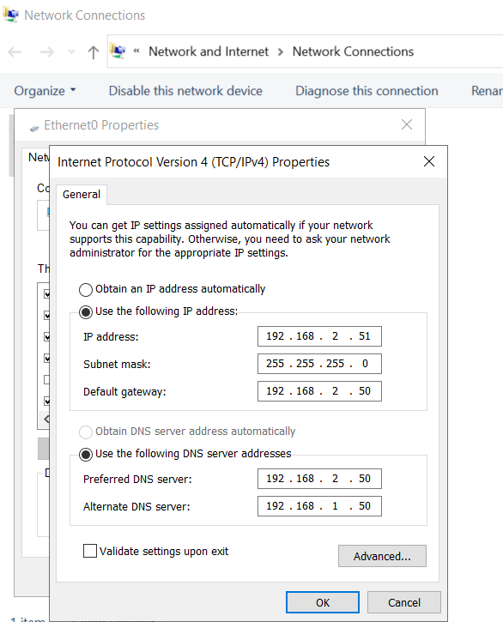

1. Install VMware Tools [Environment Specific]
2. Disable IPv6
3. Install Active Directory and configure Forward Lookup and Reverse Lookup Zones in Domain OS.
4. Disable the password complexity policy in domain
5. Disable the public, Private and domain firewalls rules in domain os.
6. Disable the public and private firewall rules in node 2 and node 3
7. Install Routing services in Active directory and configure routing services  
   [Simulating a Multi Subnet cluster for setting up SQL Server Always On Availability Groups - lab setup (sqlshack.com)](https://www.sqlshack.com/simulating-a-multi-subnet-cluster-for-setting-up-sql-server-always-on-availability-groups-lab-setup/)
8. Join the Node 1 and node 2 to domain.
9. Disable the domain firewall rule in node 2 and node3
10. Install .Net 3.5 Framework in Node 1 & Node 2
11. Install Failover clustering Feature in Node 1 & Node 2
12. Install Failover Cluster Automation Server Feature in Node 1 &Node 2 [If you want Active Active cluster otherwise skip this Step]
13. Install ssms in node1 and node2
14. Install Standalone SQL Server 2022 with sql2022hyd01 in node1
15. Install Standalone SQL Server 2022 with sql2022hyd02 in
16. Create a share folder to node1 and node2 and validate and create a cluster with file share witness quorum.
17. Enable Always on feature On Both Standalone Instances in Node 1 & Node 2 and configure always on
18. Install SQL failover cluster in node1 with (sql202201)
19. Install SQL Server With add a node to cluster Option in Node2 {Note: This works as Active - Passive SQL Cluster}
20. Restore Any Sample Databases like Adventure works for Replication Practical
21. Configure Log shipping, Mirroring & Transactional Replication

Note: Like the Video

Comment Your Ideas and Doubts

Share the video If you like

**All the Best**